2520030116 – B. Sai Sri Hasini
Skill 1
Aim:
To install and configure a Linux virtual machine, set up GCC and Git, create a project structure, understand basic shell architecture, and build an initial Makefile. The experiment also aims to study process abstraction by using fork() and the exec() family, observe parent-child relationships, inspect the process tree, and practice system call tracing.
Requirements:
Linux/Ubuntu Virtual Machine, GCC compiler, Git, Terminal, Make utility, and system-call tracing tools such as strace
. Procedure:
1. Install Ubuntu Linux in a virtual machine and open the terminal.
2. Update the package list and install GCC, Git, Make, and required development tools.
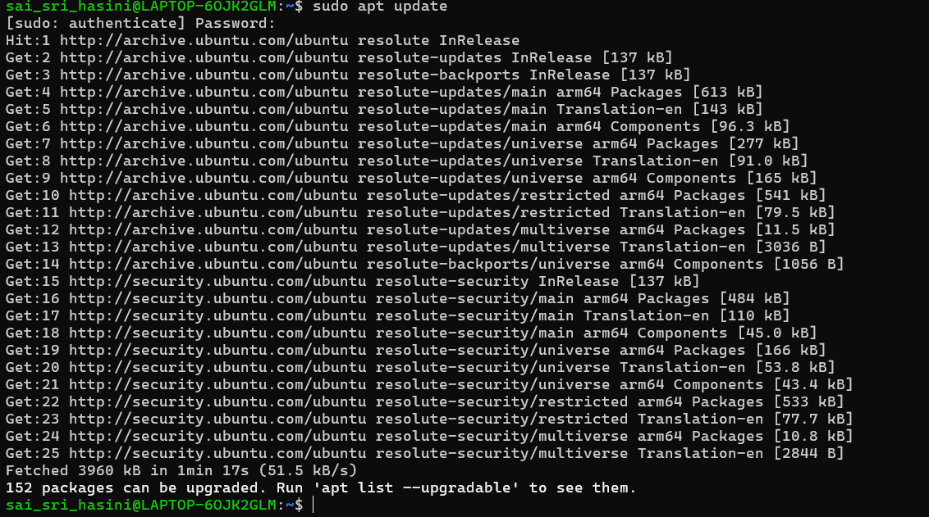
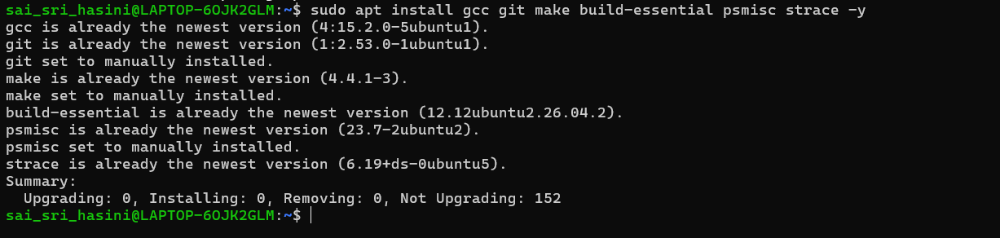
3. Verify the installation using commands such as gcc --version, git --version, and make --version.
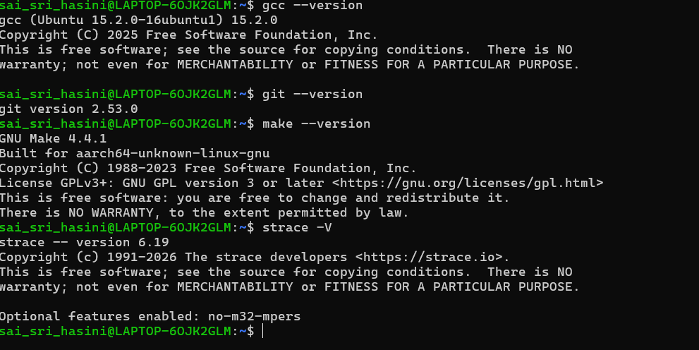
4. Configure Git using the user's name and email address.
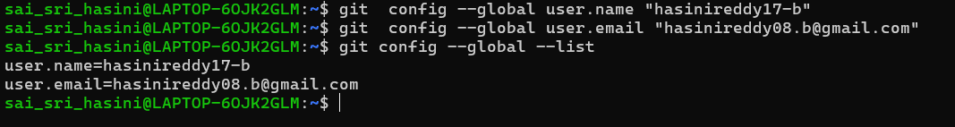
5. Create a project directory with separate folders for source files, header files, and build files.
6. Initialize the project as a Git repository using git init.
7. Create a simple C program and compile it using GCC.
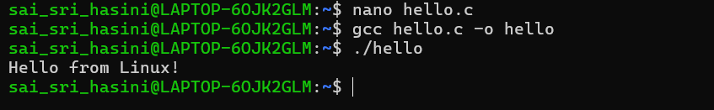
8. Create a basic Makefile to automate compilation and build the program using the make
command.
9. Study the shell architecture by understanding how the shell accepts a command, creates a
process, executes the requested program, and waits for its completion.
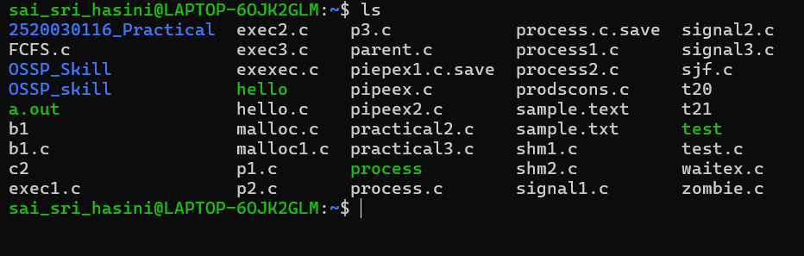
10. Write a C program using fork() to create a child process and observe the process IDs of
both the parent and child.
11. Use the exec() family of system calls to replace the child process with another program
or command.
12. Use commands such as ps, pstree, and /proc to inspect the parent-child relationship
and process tree.
13. Use strace to trace the system calls made by a program and observe calls such as
fork(), execve(), wait(), open(), and read().

Linux environment was successfully installed and configured with GCC, Git, and Make. A project structure and Git repository were created successfully. The shell was observed to act as an interface between the user and the operating system by creating and managing processes for entered commands. The fork() system call created a new child process, while exec()replaced the child process with the specified program. The parent and child processes had different process IDs and their relationship could be observed using ps and pstree. System-call tracing using strace displayed the system calls performed during program execution.
The Linux development environment was successfully configured, a Git-based project structure and Makefile were created, and the concepts of process creation, process replacement, parentchild relationships, process-tree inspection, and system-call tracing were successfully demonstrated.

